Project VII

Neil P. Parmar

Dept. of Electrical Engineering and Computer Science

Oregon State University, Corvallis, USA

parmarn@oregonstate.edu

1. Introduction

In the particular project we test the performance of the OpenCL / OpenGL particle system. The particle system is used in games, movies, etc. which depict various phenomenon. The project has been designed to bounce off from the surface of the two representational spheres. The particles, however, change their color while they touch the surface of the sphere(s). This project report firstly represents the System Configuration, the it explains the Implementation Specifications, and finally it evaluates the performance and Analysis.

1. System Configurations & Load

The particular project has been implemented in the system configurations represented in the image below in Fig 1(a) and (b) respectively. The configuration details have also been stored in the file name “SystemGPUInformation” respectively.

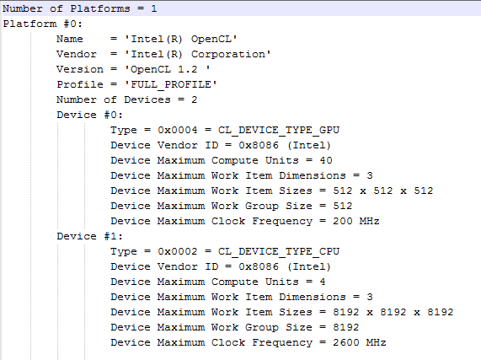 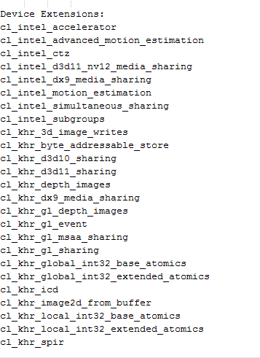

Fig 1. System Configuration. (a) Fig 1. System Configuration. (b)

1. Implementation Specifications

The main project implementation files are in the folder, namely “particle.cpp” and “NPparticle.cl”, respectively. The particular files can be found under the Particle Template respectively. Moreover, the excel file contains named “Project 7 Workbook”, contains the table and its graphical representation. Also, the images (snapshots) of the particle template could be found under the image folder respectively. These images have also been pasted at the end of this report.

1. Performance and Analysis
2. Performance (MegaParticles/sec)



Table I above demonstrates the performance of the particle system which is measured in MegaParticles/sec. The Number of Particles are basically a multiple of 1024, i.e. the range being from 1024(1K) to 2097152(2M). In the particular project, the particles change their color by a multiplying it with the current position and 0.01. As the particles color values range between 0.0 and 1.0, therefore the randomly picked a smaller number to control the growth. In this project the particles change color only if they bounce-off the surface of the sphere.

The graphical representation of the performance with respect to Table I has been shown in the image (Fig 2) displayed below.

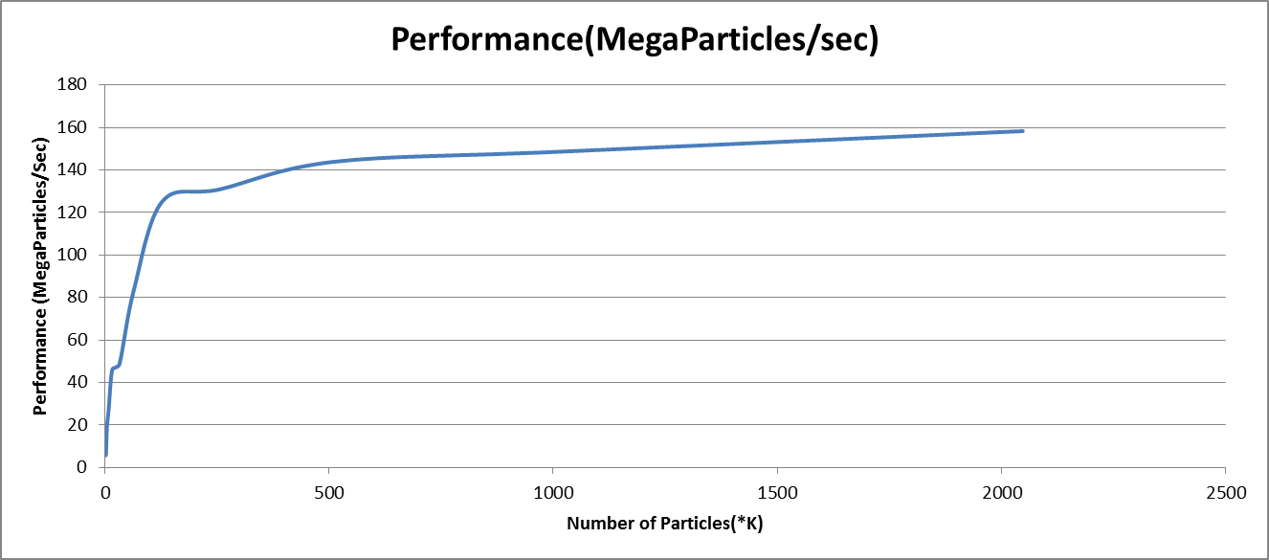

Fig 2. Performance of Particle System.

As demonstrated from the Table I and fig 2 above, the particle systems performance curve is a parabolic curve with initial values remaining significantly closer to each other, however with the increase in the number of particles, the performance also constantly increases but slowly the rate of its increase steadily becomes constant.

The performance shown above is a steady increase with the increase in the Number of Particles. A steep increase in the performance is observed for initial values of the Number of Particles (i.e. from 1K to 500K). However, these values do not show the most significant performance values and hence is therefore just for the purpose of analysis.

The pattern of the particle systems solely depends upon the number of particles (Global Work Size) with the Local Work Size being considerably constant. This can be seen from the results generated in the graph and the figure above.

Moreover, all the performance measurements have also been shown in the images below.

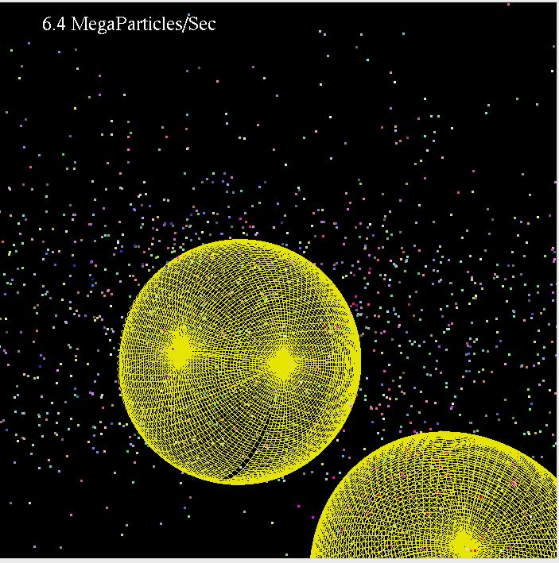 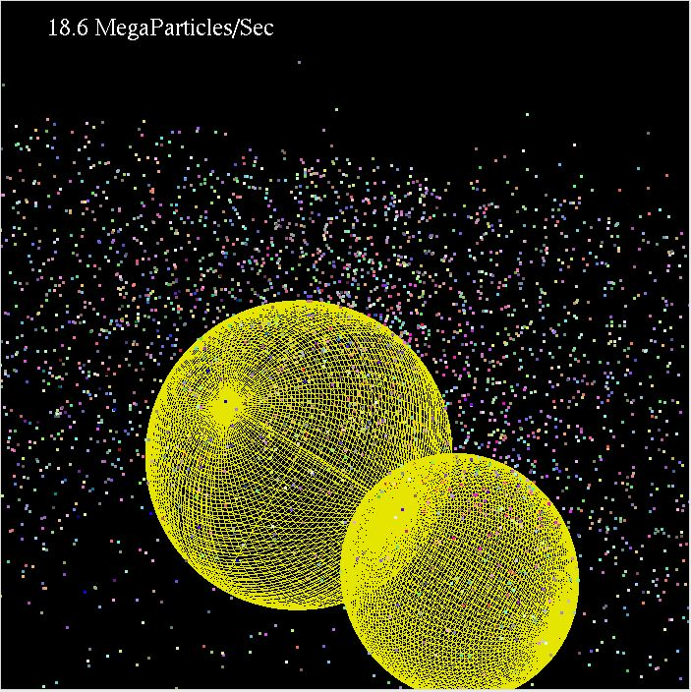

Num Particles 2 Num Particles 4

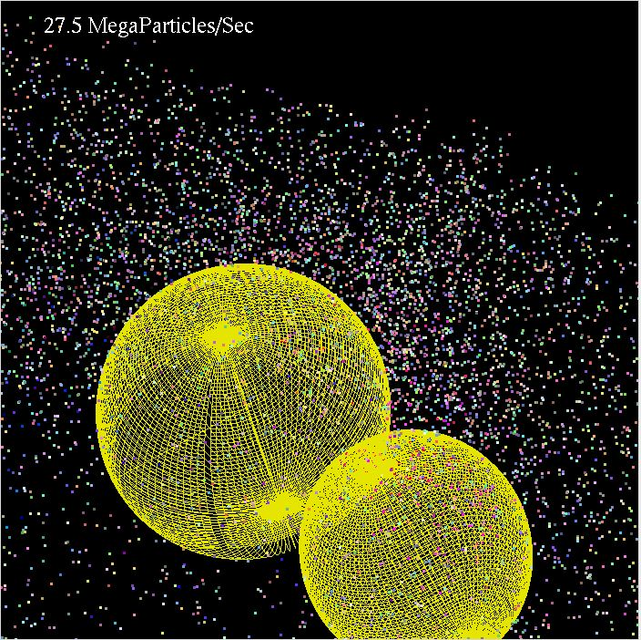 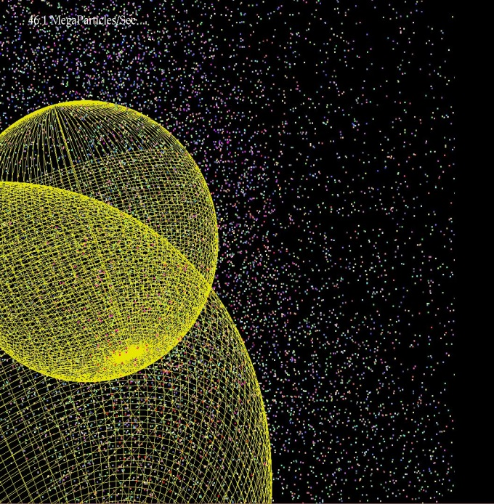

Num Particles 8 Num Particles 16

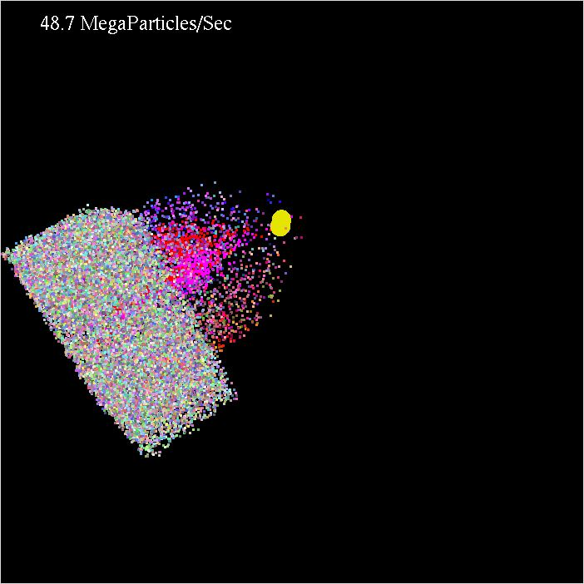 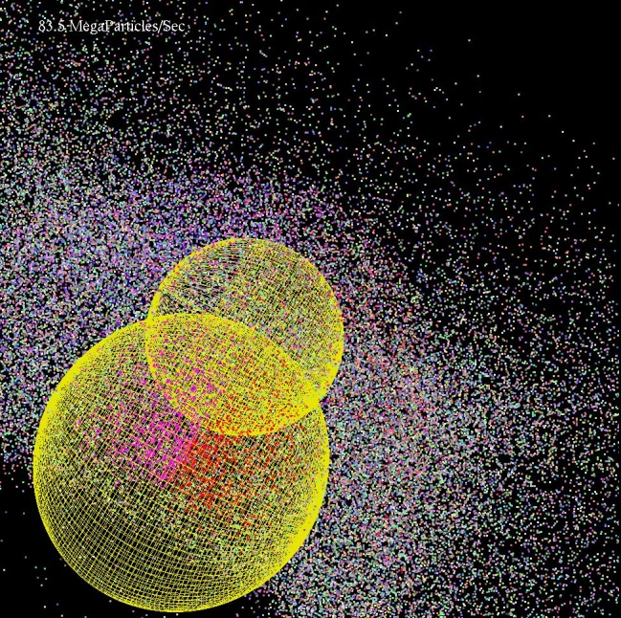

Num Particles 32 Num Particles 64

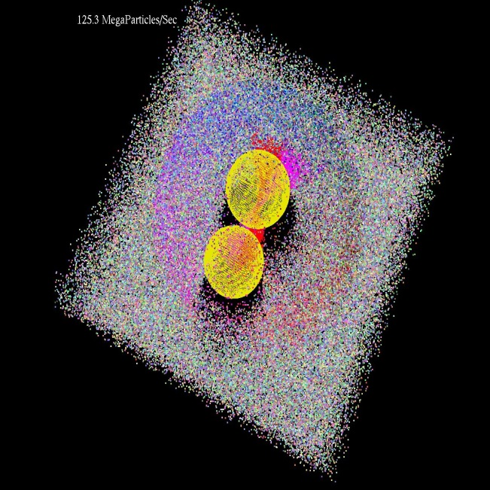 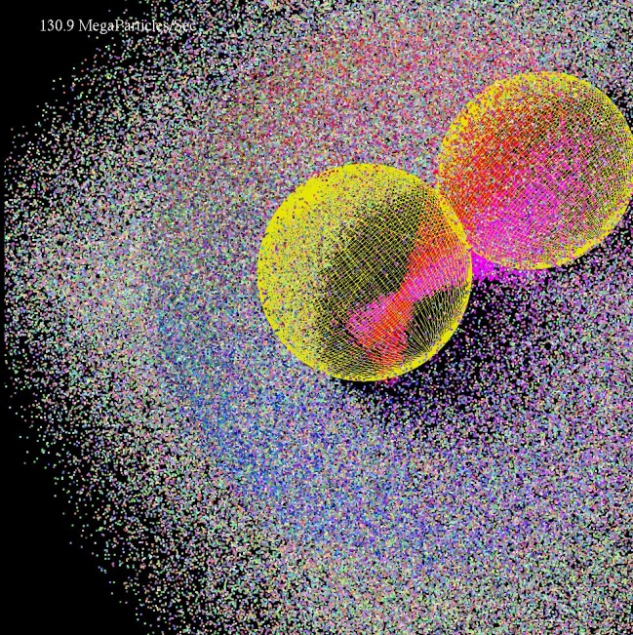

Num Particles 128 Num Particles 256

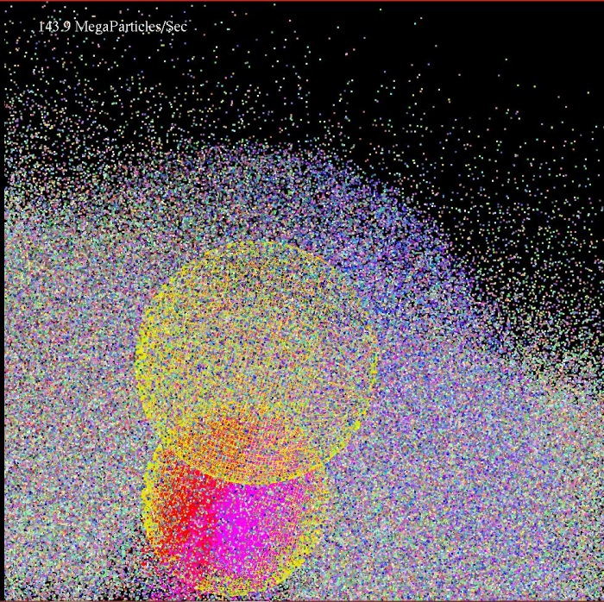 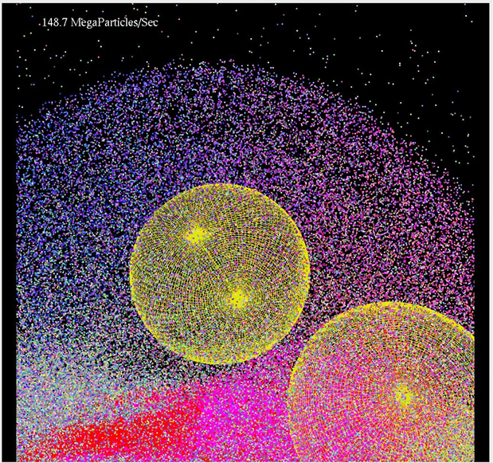

Num Particles 512 Num Particles 1024

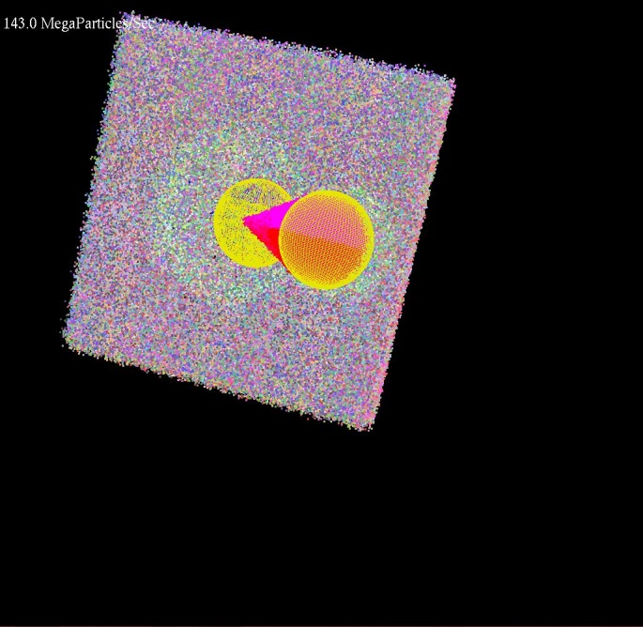 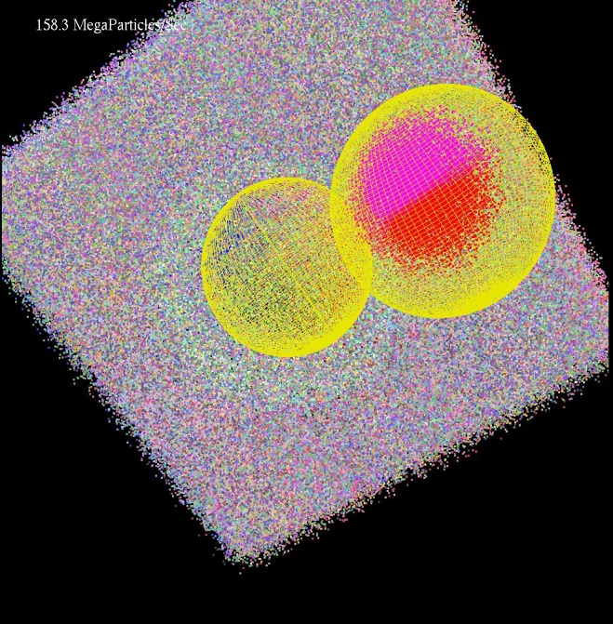

Num Particles 2048 (1) Num Particles 2048 (2)